 | 2017 Overseas Travel Study  - Travel Period & Expenditure - | Institute | Sejong Univ. Tourism Industry Research Lab.
 | 2017 Overseas Travel Study  - Travel Period & Expenditure - | Responsible  Head | Kim, Hyung-Gon, Head/Ph.D/  Prof. in Graduate school
 | 2017 Overseas Travel Study  - Travel Period & Expenditure - | Inquiry | Kim, Min-Hwa, Researcher/Ph.D
 | ‣ Released on Oct. 25, 2017  ‣ Total 4 Pages | e-mail | kimmh@consumerinsight.kr
 | ‣ Released on Oct. 25, 2017  ‣ Total 4 Pages | Phone | 02) 6004-7643
<Joint-project by Sejong Univ. Tourism Industry Research Lab. & Consumer Insight>
Overseas Trips of Last year featuring short-distance, Low-Expense,
and Japan
⦁ 82% of Korean overseas travelers traveled to Asia, with 46% of them heading out to Japan.
⦁ More Korean outbound travelers visited Osaka than Oceania while as many Koreans traveled to Fukuoka as to North America.
⦁ Korean travelers spent less than 1 million won, mostly staying 5 days and 4 nights.
⦁ Trips to Europe, Central and South America, and Africa cost approximately 3 million won, needing typically more than 10 days.

Travel period and costs vary greatly by travel destination. The average travel period answered by 14,000 overseas travelers was 6.1 days, and the total average expense was 1,531,000 won, with about 252,000 won spent each day. However, the Asian region, to which more than 80% of the travelers had traveled to, took up far less time and expense compared to other travel destinations. The short distance, short period, low expenses of overseas travels are the mainstream and there was Japan in its center.

Last September, Sejong University Tourism Industry Research Lab. and Consumer Insight-a firm specialized in travel research-surveyed a sample of 14,214 people that traveled overseas this past year (September 2016 ~ August 2017) on their travel destinations, period, and cost. Travel time and expenditures varied greatly depending on their destinations. More than half (54%) of the sample group answered that they traveled overseas this past year, and that on average, they traveled overseas about 1.2 times over the same period. [Figure 1]

[Figure 1] Overseas Traveling Experiences and Regions (In the Past 12 Months)

▲Asia was the most visited region by more than four-fifth(82.1%) of overseas travelers, followed by Europe 14.7%, Oceania 11.5%, North America(including Hawaii) 8.8%, the Middle East 1.2%, Central and South America 1.0%, Africa 0.7%, and others 1.4%. Those who traveled to Europe visited 2.83 countries on average and only a third (35%) of them visited one country.

▲The most popular destination was Japan, attracting 37.7% of overseas travelers and 45.9% of Asian travelers. In terms of regions within Japan, Osaka accounted for 12.4% of total overseas travels-surpassing Oceania (11.5%)-followed by Fukuoka 8.6%, Tokyo 6.4%, Okinawa 3.7%, and Sapporo 2.9%. After Japan, other Asian countries followed in the respective order: China, Vietnam, Thailand, Philippines, Taiwan, Hong Kong. Only a few countries in the Americas, Oceania and Europe made it in the top ten list, which included the U.S. at number eight, Guam at number nine, and France at number ten.

Travel period and expenses by major continents were compared. <Table 1>. ▲On average, traveling to Asian region required 4.6 days and 983,000 won, with 213,000 won spent per day. Among the 7 continents (Asia, Europe, Oceania, North America, Middle East, Central and South America, Africa), traveling to Asia took the shortest period and lowest cost. Next was ▲Oceania, which took 6.2 days and 1,692,000 won, with 272,000 won spent per day. Meanwhile, travels to Europe, Central and South America, and Africa required more than 10 days and 3 million won. The longest average travel period was in Latin America, with 11.6 days. The region that required the most total and daily travel expenses, was Africa (3,633,000 won in total and 339,000 won per day).

<Table 1> Travel Period and Expenses by Region
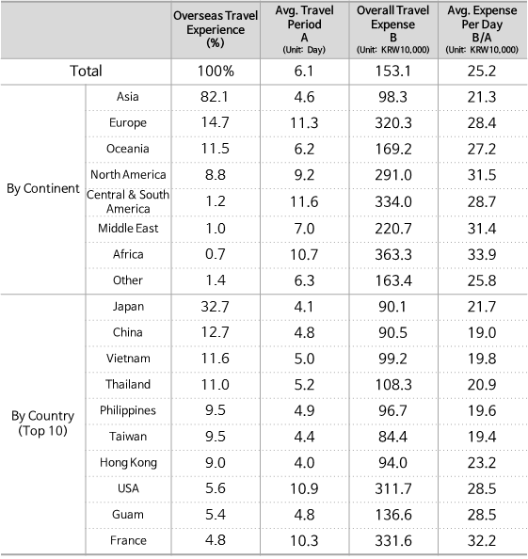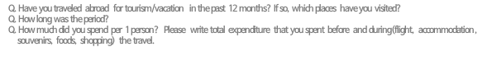
Examining the travel period and cost of the most-visited countries in Asia, ▲the country with the longest travel period was Thailand (5.2days), while the shortest travel period was Hong Kong (4.0 days). ▲Total travel expenses were highest in Thailand (1,083,000 won) and lowest in Taiwan (844,000 won). ▲The average daily expenses were highest in Hong Kong (232,000 won) and lowest in China (190,000 won). In summary, most trips by Korean tourists to the Asian region were made with a budget of ▲approximately 1 million won, ▲with 200,000 won spent per day on average, ▲and a 5-days and 4-nights of schedule(4 days and 3 nights for Japan and Hong Kong), which were mostly short-time period, short-distance, and low-expenses trips.

-----------------------------------------------------------------------------------------------
∙ Research and Survey Methods
Sejong University Tourism Industry Research Lab. and Consumer Insight conducted a joint-survey on overseas tourists to gather information on their experiences this past year (September 2016 ~ August 2017) and their evaluation of vacation packages. With Consumer Insight's 800,000 IBP (Invitation Based Panel) as a sampling frame, a sample group of 26,100 people participated. The sampling method was based on population ratio, participants were chosen based on proportional allocation based on sex, age, and region. Email and mobile devices were used for data collection.
-----------------------------------------------------------------------------------------------
“The press releases of Sejong Tourism Industry Research Lab.·Consumer Trend Research Lab. of Consumer Insights are listed on the website (www.consumerinsight.kr/etravel)”

Please contact the personnel listed below for detailed contents of this press release.

Chief researcher/Ph.D. Kim, Min-Hwa kimmh@consumerinsight.kr 02)6004-7643
Senior researcher/Ph.D. Jung, Kyung-Sik jungks@consumerinsight.kr 02)6004-7627
Junior researcher/B.P.S Jang, Yeong-eun jangye@consumerinsight.kr 02)6004-7631
* A part of or the entire contents cannot be used without written approval of the releasing party *

